DATA ANALYTICS

ASSIGNMENT 7

DECISION TREES

TEAM MEMBERS

NAME SRN  
VIMARSHA R PES1201701590

VINUTHA M N PES1201701373

KEERTHI PRIYA P PES1201701643

DECISION TREES:

A decision tree is a map of the possible outcomes of a series of related choices. It allows an individual or organization to weigh possible actions against one another based on their costs, probabilities, and benefits. They can be used either to drive informal discussion or to map out an algorithm that predicts the best choice mathematically.

A decision tree typically starts with a single node, which branches into possible outcomes. Each of those outcomes leads to additional nodes, which branch off into other possibilities. This gives it a treelike shape.

Below is the implementation of decision tree which calculates entropy and information gain for the features and also creates a picture of decision tree.

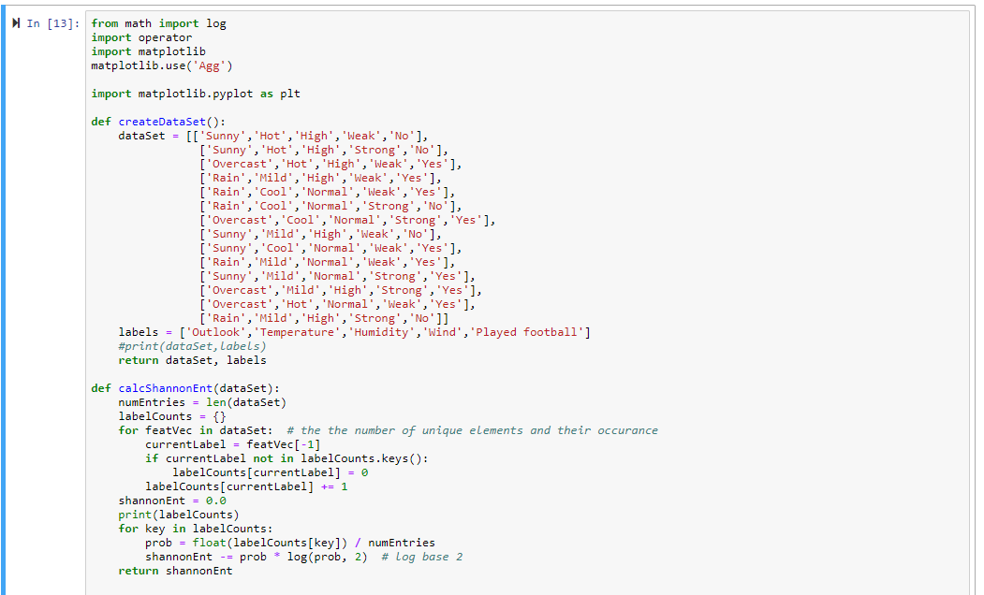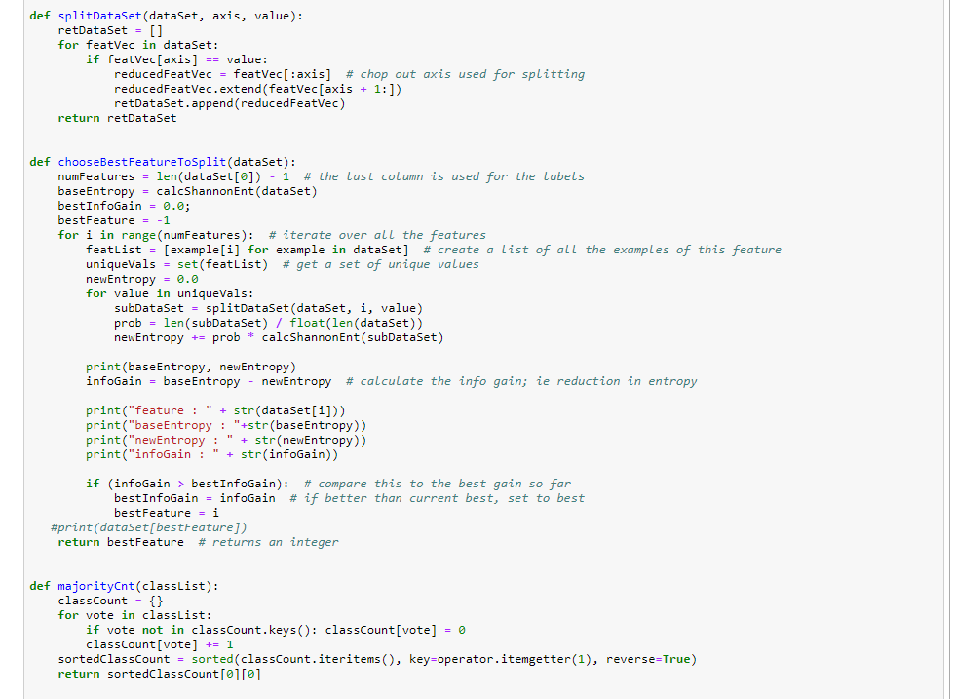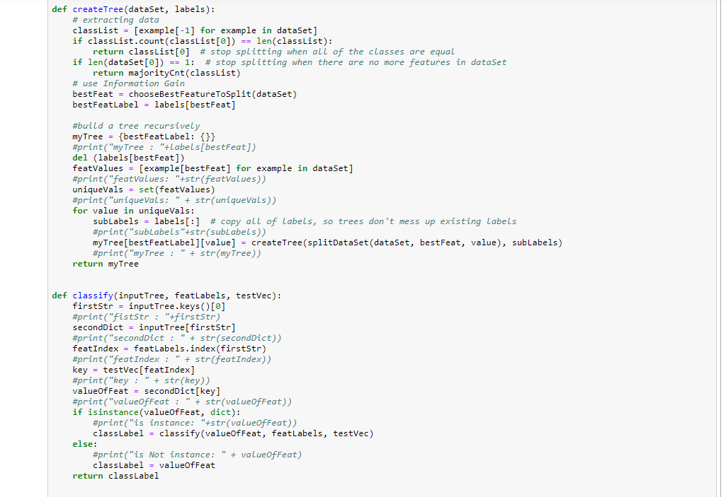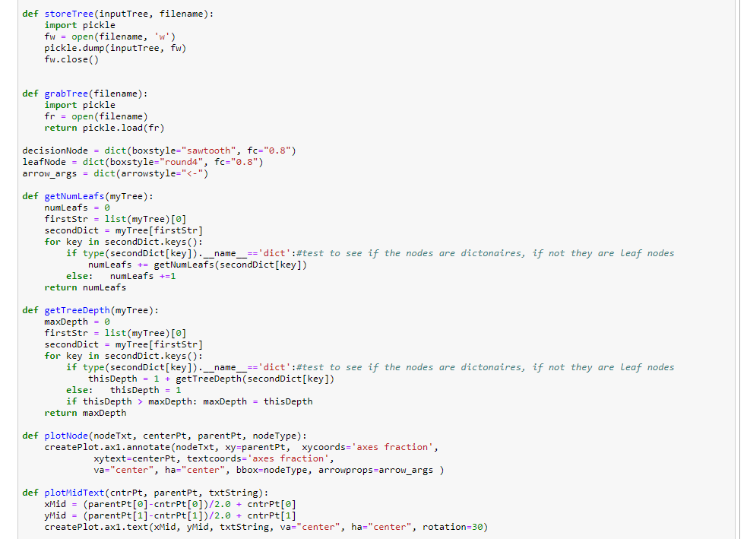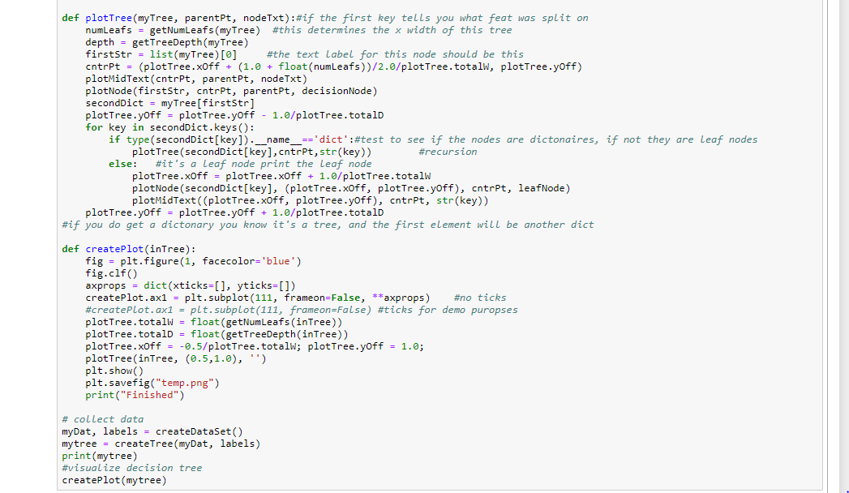

OUTPUT:

